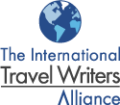
Destination Holland

I am pleased to attach Destination Holland, which has been produced by the International Travel Writers Alliance with the support of The Netherlands Board of Tourism.  It provides a media resource for Alliance members and other professional travel writers, editors, broadcasters and photographers.  The Netherlands Board of Tourism will be delighted to provide Alliance members with more information and to discuss potential press trips.  Contact : Evelina Sugintaite  Netherlands Board of Tourism & Conventions  PO Box 30783, London WC2B 6DH  T: +44 (0) 20 7539 7957 (not for publication)  F: +44 (0) 20 7539 7953  E: esugintaite@holland.com  W: www.holland.com  Ashley Gibbins  The International Travel Writers Alliance | 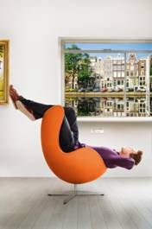

Destination Holland is supported by

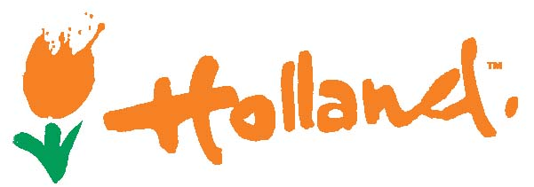

www.holland.com

Destination

Holland

Holland

The Netherlands – more often called Holland - is located in North-western Europe and borders the North Sea to the north and west, Belgium to the south and Germany to the east.

For historical reasons, the government and parliament are in The Hague, although Amsterdam is the capital.

Holland is a constitutional monarchy with a parliamentary system of government. Queen Beatrix is the head of state and has a coalition government.

The Language

Dutch is the national language of Holland. However, English is spoken by almost everyone.

The people in the northern province of Friesland speak a language known as Fries, in addition to Dutch. More than 90 percent of the residents of Friesland understand the Friesian language, nearly three-quarters speak it, 65 percent read it and some 70 percent can write it.

Facts and figures

Holland has a surface area of 41,528 square kilometres with the greatest distance from north to south 300 kilometres, and from west to east 200 kilometres.

Holland is one of the most densely populated countries in the world. It has a population of 16,500,000 and an average of over 400 inhabitants per square kilometre.

The lowest point in Holland is 6.76 metres below sea-level.

www.holland.com

Working with the Alliance

Destination Holland has been produced by the International Travel Writers Alliance with the support of The Netherlands Board of Tourism.

It provides a media resource for professionals looking to visit Holland to write, broadcast or create images that will highlight the country.

The Netherlands Board of Tourism will be delighted to talk to Alliance members about sourcing other story and feature ideas and future press trips.

Key media contacts

UK media should contact:

For more information about Holland and images contact:

Evelina Sugintaite

Netherlands Board of Tourism & Conventions
PO Box 30783, London WC2B 6DH

T: +44 (0) 20 7539 7957 (not for publication)
F: +44 (0) 20 7539 7953
E: esugintaite@holland.com
W: www.holland.com

Reasons to write about Holland

The cities

The cities of Holland provide the focal point of most visitor experiences with easy access to the surrounding countryside.

The key Dutch cities are:

- Amsterdam
- The Hague
- Rotterdam
- Utrecht
- Maastricht

Amsterdam

Amsterdam, the capital and largest city in Holland, also has Europe’s largest and best-preserved historic centre.

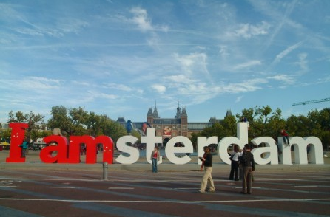 | As such it is one of the world’s most alluring cities, with hundreds of 17th century houses, canals and museums where masters such as Van Gogh and Rembrandt are on permanent display.  It is also known for its relaxed atmosphere.  Amsterdam can be enjoyed any time of year although it truly comes alive in summer with many festivals, parades and concerts on canal stages.

The tiny towns and villages just outside Amsterdam offer a rich tradition and typical Dutch landscapes with windmills, dikes and in late spring millions of blooming tulips.

www.iamsterdam.com

The Hague

The Hague is the seat of the Dutch government and the residence of the royal family.

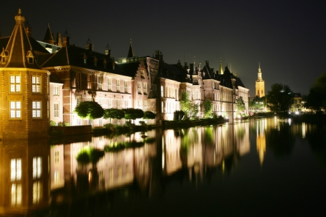 | It is the third largest city in Holland and capital of the province of Zuid- Holland and lies close to the North Sea.  With its wide streets, spacious squares and promenades and fine residential suburbs it is a very elegant and attractive city that hosts many events during the spring and summer.

During the summer months many visitors also come to this area to enjoy the beaches and seaside resorts of Scheveningen and Kijkduin.

www.denhaag.nl/en.htm

Rotterdam

Rotterdam, which is the second largest city in Holland, lies on both banks of the Nieuwe Maas, the southern arm of the Rhine

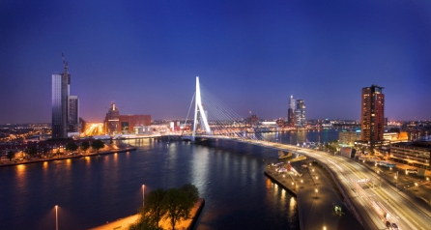 | With the opening of the Europoort in 1966 Rotterdam became the the largest port in the world in the volume of goods handled.  Central Rotterdam was almost completely destroyed by German air attacks in 1940.

This has enabled the emergence of one of the modern cosmopolitan cities of Europe with a truly vibrant nightlife and a distinct skyline.

www.rotterdam.info

Utrecht

Utrecht is one of the oldest cities in Holland with a vibrant historic city centre surrounded by 13th-century canal wharves.

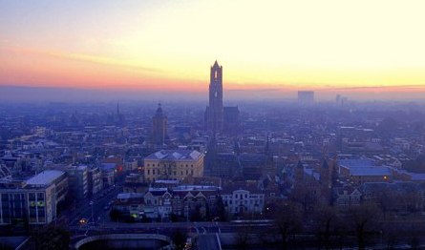 | Situated below street level, the streets alongside bustle with shops, restaurants and cafés.  The old medieval centre of Utrecht kindles a passion for the past! Stroll along the century-old canals, and past the stately houses and wharves.  Here you can sample the pleasant, intimate atmosphere for which Utrecht is famous.
All year around Utrecht hosts various cultural events full of music, dance, theatre and art. The city’s student community, the largest in the country, gives the city a youthful vibrancy.

www.UtrechtYourWay.com

Maastricht

The beautiful city of Maastricht may owe its importance to its strategic situation on the Dutch-Belgian-German frontier.

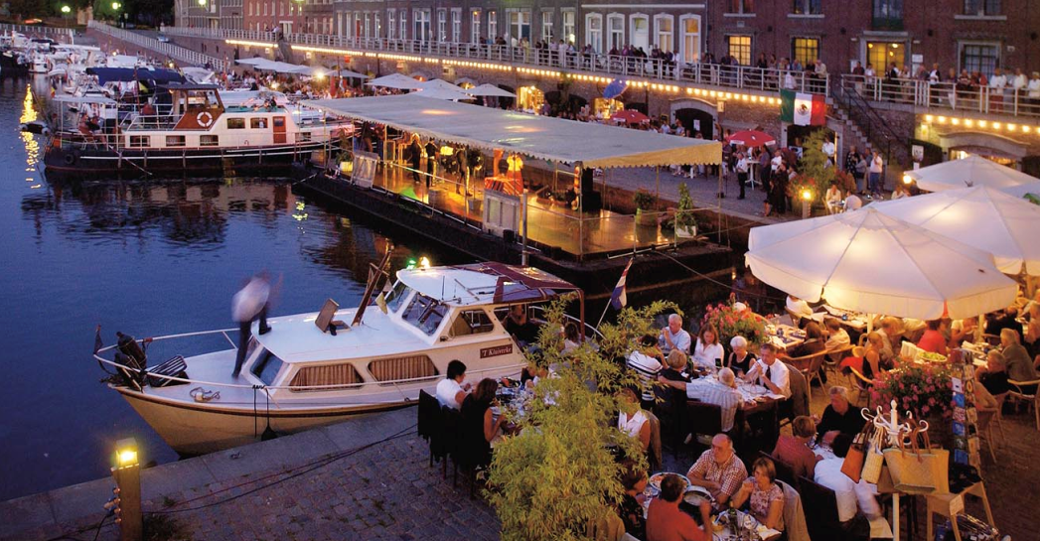 | However, the lure for visitors is more likely to be its historic buildings and art treasures.  Maastricht offers Spanish and Roman ruins, French and Belgian influenced architecture and a cosmopolitan ambience, world-class dining and an elegant atmosphere.
The signing of the "Maastricht Treaty" in 1992 has seen the town become the symbol of the European Union. The Summit Meeting of the (then) 12 member states was held in Linberg House in the city.

www.vvv-maastricht.eu/home.html

Reasons to write about Holland

City life in Amsterdam

Water Sensations

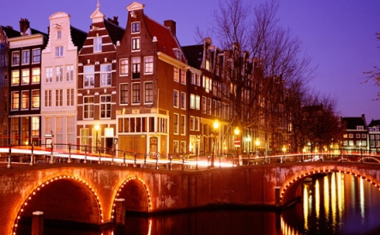 | A large number of events on and around Amsterdam’s many waterways will take place in 2010.  These include Amsterdam Water Sensations, which reveals how ‘Amsterdammers’ (residents of Amsterdam) live their lives on the waterside to the fullest extent

Giro d'Italia

In May, the Italian cycling race Giro d'Italia will start alongside the canals of Amsterdam and comprise a 10-day Italian festival called Giro Mania!

Giromania! combines the best of Amsterdam with the best of Italy offering something for sports fans, culture fanatics and followers of fashion alike.

The Italian festival in Amsterdam will combine international allure with the intimacy of an Amsterdam party, all centred around the bicycle, as a means of transport, recreation and competition.

Highlights of Giro d’Italia include:

- 8 May 2010 : cyclists riding along the canals and the Amstel River
- 9 May 2010 : cyclists riding along the waterways and lakes around Amsterdam
- 10 May 2010 : cyclists riding along the beach

Amsterdam SAIL
19-23 August

Amsterdam SAIL takes place every five years and is one of the largest maritime events of the world.

Entry is free and expected are an impressive fleet of tall ships, sailing monuments, modern high-tech ships, war ships and replica.

SAIL Amsterdam 2010 is themed as “A nautical meeting of past, present and future!”

Other events

Amsterdam Canal Museums - Open Garden Days
18-20 June 2010

The Canal Museums - Open Garden Days gives the public the chance to visit approximately thirty canal gardens located behind/next to the canal houses of Amsterdam. This year the theme is Community Gardens

Amsterdam’s Gay Pride
1-8 August 2010

The highlight of Amsterdam’s Gay Pride will be an extravagant carnival boat parade through the Amsterdam canals on 7 August.

Bungalow 8 to open in Amsterdam

A new club will be opening in May in Amsterdam. The popular New York and London celebrity hang-out Bungalow 8 is coming to the city.

The Amsterdam branch of Bungalow 8 will open their doors on the Korte Leidse Dwarsstraat, where previously the Zebra Lounge resided.

www.iamsterdam.com

City life in The Hague

Royal City by the Sea

Scheveningen is a popular beach resort in The Hague.

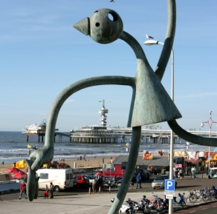 | The beach and the dunes have plenty to offer sport enthusiasts from sailing, (kite) surfing, fishing and diving plus many other water sports activities.  As of mid-July 2009, surfers can now stay overnight in sea containers on the beach at the northern side of the jetty harbour in Scheveningen.  F.A.S.T. (Free Architecture Surf Terrain) is a unique and artistic surfers’ village on the boulevard of Scheveningen.

Madurodam

The world-famous miniature city of Madurodam presents everything Holland is famous for, replicated to the smallest detail on a scale of 1:25.

New for 2010 and exclusive to Madurodam is the Madurodammertje, a new cheese, which weighs in at half a kilo and has a traditional ‘Gouda’ shape. In cheese terms it is referred to as a flat cheese.

In order to develop its semi-mature flavour it is matured for approximately 3 months.

The Madurodammertje is produced exclusively with milk from South Holland and is therefore a local product. The cheese will be on sale in Madurodam during the tourist season starting in April.
Madurodam by Light
When twilight falls thousands of tiny lights create a fairytale atmosphere in the miniature city. A spectacular show can be seen in Madurodam: Madurodam by Light.
Every evening after sunset visitors will be submerged into a fascinating Dutch fairytale that tells the story of Hansje Brinker and the fight against the water.
Madurodam uses the most modern projection techniques for this show of water, light and lasers.

International Fireworks Festival
19 - 21 August

Firework shows will take place in August during the Friday Night Summer Fireworks series and will be followed by the spectacular International Firework Festival in Scheveningen.

The Hague Festivals

Throughout 2010, The Hague will host a variety of events, the highlight of which takes place during the month of June and is known as ‘The Hague Festivals’.

After three successful editions, the fourth edition of The Hague Festivals will run from 10-27 June 2010.

Events will include :

- Flag Day Scheveningen - an event that celebrates the arrival of the New Dutch Herring
- The Hague Jazz
- Festival Classique
- PopHotSpot
- The Hague Sculpture
- Shopping Night, and
- Dutch Veterans Day and Parkpop.

www.denhaag.nl/en.htm

City life in Rotterdam

Le Tour de France
1-4 July

Rotterdam will host the start of the Tour de France and it is the fifth time that Holland has hosted the world’s best known cycling event.

In the run-up to the start of the Tour all kind of events will be organized in the city within the theme ‘New Energy.’

- Thursday 1 July

Rotterdam will welcome the Tour de France teams and their cyclists. On stage, all teams and their cyclists will be presented to the public.

- Friday 2 July

Programme to be confirmed

- Saturday 3 July

The Tour de France starts from Zuidplein, on the south bank of Rotterdam.

This part of Rotterdam has a long sporting history being the home of football club Feyenoord and also houses Sporting Arena Ahoy where many internationally known sporting events take place annually including :

- the Rabobank Six-Day Cycling Race, and
- the ABN AMRO World Tennis Tournament.

The official start will take place on 4 July on the Erasmus bridge
The Tour de France route through Rotterdam is approximately 9 kilometres long and runs via the Dordtselaan, Maashaven O.Z., Hillelaan and Posthumalaan to the Erasmus Bridge.
On the north bank, the cyclists will follow the Boompjes, back to the south bank over the Extended Willems Bridge, the Noordereiland, the Koninginne Bridge, the Stieltjesstraat, the Laan op Zuid to the Dordtselaan which leads back to the finish at Zuidplein.

Sunday 4 July

The 97th edition of the Tour de France will set out from the centre of the Erasmus Bridge in Rotterdam.

Cyclists will head towards the province of Zeeland over the Zeeland islands to Brussels in Belgium.

Greener Rotterdam
Rotterdam has vowed to reduce CO2 emissions in the harbour and the city by 50 per cent by the year 2025.

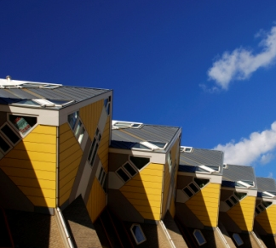 | Together, local businesses, residents and the municipality are investing largely into creating a sustainable city.  Former US President Bill Clinton previously asked Rotterdam to become part of the Clinton Climate Initiative, a group of 40 large cities setting out to make a difference together.  Cycling is an alternative mode of transport and an example of sustainability.

Within the framework of Le Grand Départ Tour de France, the city of Rotterdam will take the opportunity to communicate this message within the city, Holland and rest of the world.

The culinary Capital of Holland 2010
Rotterdam has been voted Culinary Capital of Holland by restaurant guide SpecialBite after Restaurant Ivy was ranked number one in their magazine.

Serving international cuisine, this restaurant has also been awarded a Michelin star.

www.rotterdam.info

City life in Ultrecht

Cultural Sundays in Utrecht

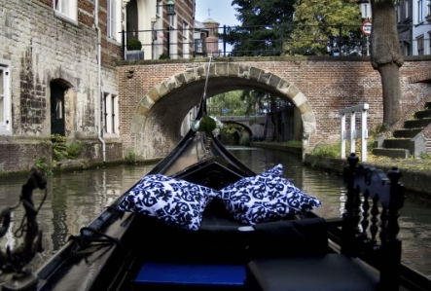 | Utrecht hosts cultural festivals all year round, and has developed ‘Cultural Sundays’; special days with a lively programme full of theatre, dance, music, films, workshops, etc. on large and small stages, on squares and in parks.  Entry is usually free and a selection is highlighted below.

Dance Sunday:
24 May 2010 (actually Whit Monday)

Urban and world dance, traditional and modern dance by professionals and amateurs of any age take to the streets and the stages

Outside Festival
5 and 6 June 2010

A national cultural sports festival at a large number of locations throughout the city, with sports, music, dance, theatre, literature, demonstrations, talk shows and much, much more!

Una Domenica Particolare
19 December

'Una domenica particolare' is all about Italian culture in the broadest sense of the word: Italian opera, film, literature, music, dance, theatre, cuisine and made in Italy.

Utrecht is all a glow : ‘Trajectum Lumen’
From April 2010

The historic city centre of Utrecht will become a backdrop of theatrical light art.

Encompassing churches and basements, bridges and castles, canals and wharves, which in the evening will be transformed into a work of art in light.

Trajectum Lumen will start with approximately 20 illuminated objects. Until 2013, up to 20 new art works will be added to the route. The plans are to keep the route illuminated until 2018.

Giro d’Italia, arrival in Utrecht

On 9 May 2010, the second stage of the Giro d’Italia finishes in Utrecht.

The route covers various regions and cities in the province of Utrecht with cyclists eventually following the trail of the Romans.

The total length of the route is 209 kilometres. The last of the 30 kilometres covers the city areas of Utrecht.

Explore Utrecht on Skates

The Skate Parade holds free roller-skating trips through and around Utrecht on Friday evenings from early May until mid-September.

Each trip is new and takes in the nicest sights in Utrecht, with a break at a wonderful location halfway through the 22 kilometre tour.

In 2010 Utrecht celebrates the 10-year jubilee of the Utrecht Skate Parade.

www.UtrechtYourWay.com

City life in Maastricht

City of Culture

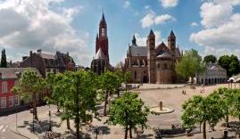 | Maastricht is a candidate for the Cultural Capital of Europe 2018.  The Maastricht 2018 initiative hopes to present the specific qualities of the region to Europe by means of an internationally appealing programme of artistic productions, amateur art and folk culture.

The European Fine Art Fair (TEFAF)
12 - 21 March 2010.

As a visitor to TEFAF you will experience the very best in fine art and the chance to view and to buy paintings from Bruegel to Bacon as well as objects reflecting 6,000 years of excellence in the applied arts.

On display will be a selection of genuine masterpieces from 239 of the world’s most prestigious international dealers.

Every item is checked by one of 25 vetting committees made up of over 155 internationally respected experts.

The Bonnefantenmuseum

The Bonnefantenmuseum on the banks of the river Maas is housed in a landmark modernist building with a striking dome, designed by Aldo Rossi.

It has an impressive collection of old masters as well as contemporary art from around the world.

The National History Museum

At the National History Museum you can come face-to-face with some of Maastricht's oldest residents. Immerse yourself in startling displays featuring the remains of a Mosasaurier excavated from the St. Pietersberg caves.

Treasure St. Servatius Basilica

Treasure St. Servatius Basilica combines a unique mixture of tradition, history, religious culture and architecture. At the Basilica, some of Maastricht's greatest treasures can be found.

Maastricht festivals

Maastricht also hosts a number of annual festivals including :

- Maastricht Toneelstad Festival from 6 to 16 May, which involves a week of theatre with performances and a particular focus on new developments in the theatre-world.

- the Festival Zomeravonden in August presents theatre, dance, music and workshops.

Gastronomic city

Maastricht is well know for its diverse cuisine and selection of outstanding restaurants, some with Michelin stars. Vineyards can also be found in the city, and local produce includes a distinctive mustard.

Preuvenemint
26 to 29 August 2010

Visitors to the city can also enjoy culinary delights and music at the 29th annual Preuvenemint festival.

FLO Maastricht

FLO Maastricht is the perfect location for anyone who loves French cuisine and good food in general.

This restaurant has a Parisian atmosphere, with one of the highlights being a large buffet of fresh crustaceans and shell fish located at the entrance.

At FLO Maastricht you can enjoy an extensive selection of the best oysters, shell fish and champagne.

The menu contains traditional French dishes and creative culinary delights made with high quality ingredients.

Shopping in the city

One of Maastricht's highlights is the book shop located in the Domincanen Monastery.

The interior decor is unique, the history fascinating and there is also a significant number of English-language books on sale.

Shopping outlets in the city include boutiques, galleries, speciality stores in Stokstraat, Jekerkwartier and Wyck and the Mosae Forum and Entre Deux shopping centres.

www.vvv-maastricht.eu/home.html

Reasons to write about Holland

Holland art cities

In 2010, the four largest cities in Holland are taking part in a large-scale art and cultural event called ‘Holland Art Cities’.

The top ten museums in Amsterdam, Rotterdam, The Hague and Utrecht have joined forces to put together an unprecedented art spectacle, a selection of which is listed below.

Hermitage Amsterdam

At the Amstel river lies the newly renovated Hermitage Amsterdam. This impressive museum is the largest branch of the world famous Hermitage in St. Petersburg, Russia.

On 6 March, the museum will reopen with the exhibition Matisse to Malevich.

The exhibition runs until 17 September 2010 and highlights of the pioneers of modernism will be on display, from Picasso and De Vlaminck to Van Dongen.

Museum Boijmans van Beuningen in Rotterdam
In autumn 2010, Museum Boijmans van Beuningen will present the Rotterdam-born artist Kees van Dongen.

The artist made quite a name for himself in Paris at the turn of the century whilst sharing a studio with Picasso.

Through a selection of eighty paintings, the exhibition charts Van Dongen’s early years and later international success.

Mauritshuis in The Hague

This museum is one of Holland's most beautiful classicist buildings and home to one of the world's leading collections of the 17th century Dutch masterpieces including ‘The Girl with the Pearl Earring’ painted by Vermeer.

- 25 March - 27 June 2010 : Room for art, in 17th-century Antwerp
- 12 May - 22 August 2010 : The Young Vermeer
- 4 November - 30 January 2011: Made in Holland, Old masters from a private collection in America

Centraal Museum in Utrecht

Until 16 May 2010, the Centraal Museum will host the exhibition ‘Fashion for Thought’ by Alexander van Slobbe.

Fashion designer Alexander van Slobbe is one of the pioneers who established Holland’s fashion reputation.

In this exhibition he provides an insight into the latest developments in society and in fashion. Van Slobbe realises this by emphasising the whole artistic process.

www.hollandartcities.com

Reasons to write about Holland

Classic Holland

Keukenhof

Keukenhof, also known as the Garden of Europe, is situated in Lisse, and is the world's largest flower garden. Over seven million flower bulbs are planted annually in the park.

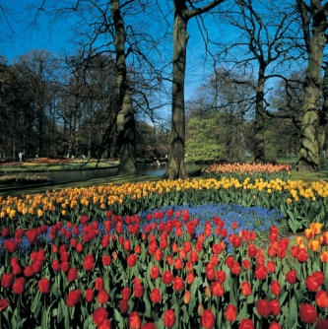 | A spectacular flower bulb mosaic of Russia’s St. Basil’s Cathedral will be the pinnacle of the ‘From Russia with Love’ theme at the Keukenhof this year.  From 18 March - 16 May, the mosaic will portray an impression of the towers which frame the centuries’ old cathedral on Moscow’s Red Square.  The mosaic cathedral measures 21 by 21 metres and has been created from almost 65,000 flower bulbs. Its colourful magnificence will be revealed at the Keukenhof this spring.

Gone with the Wind at Keukenhof

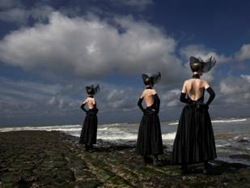 | The fashion exhibition Gone with the Wind in the Juliana pavilion at Keukenhof will focus on the creative ideas of the Dutch fashion world.  It represents a selection of traditional costumes and contemporary fashions from the Zuiderzeemuseum collection.  Outfits by Francisco van Benthum, Alexander van Slobbe, Spijkers & Spijkers and Viktor & Rolf will be on display.
Also part of the exhibition is a jewellery design by Ted Noten, where the traditional Urk men’s earring blends with the street culture of today.

Fashion designer Jan Taminiau has also created a bridal gown and matching suit for the exhibition.

www.keukenhof.nl

Reasons to write about Holland

Country fun

Flevoland

Inspiring Land Art in Flevoland

The Flevoland countryside is a fascinating design in its own right, where many renowned architects and artists have left their mark.

See the most striking buildings, including five of the seven works of Land Art in Holland, which lie ‘hidden’ in the countryside.

One of the works, The Aardzee (Earth Sea) by Piet Slegers, measures 50,000 square metres and connects the contrasting elements of earth and water.

Walk through it zig-zagging across shell paths secluded by stone fragments and embankments. Others include, the cathedral made of 178 Italian poplars, or a garden that, according to artist Daniel Libeskind, is intended for meditation.

Libeskind is also the architect for the new buildings at ‘Ground Zero’ in New York.

De Paviljoens museum
Sundays from 2 May – 27 June

Day excursions to view and experience the works of Land Art.

Batavia Wharf

In 1985, on the undeveloped coast of Leylstad, Flevoland, shipwright William Vos built a shipyard specialising in 17th century naval architecture.

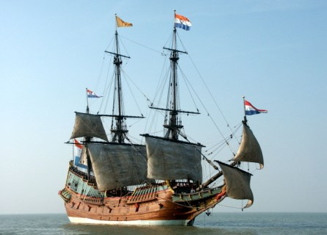 | Since then, the shipyard has become a popular tourist attraction, with highlights including:  - three museums which focus on the history of the marine industry, a shopping precinct including the Batavia  - Stad fashion outlet, a brewery producing Lelystad’s own beer and a selection of restaurants.
Batavia harbour (the largest harbour in Holland) is currently being developed into a maritime events centre where national and international sailing competitions will be organised.

The Tulip Bulb Route

The Tulip Bulb route in Flevoland is named by National Geographic Traveller as one of the finest driving routes in the world.

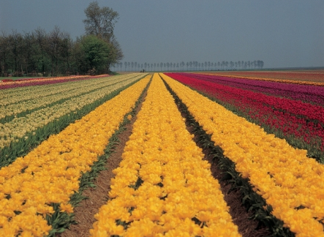 | The Noordoostpolder is home to the largest bulbfields in Holland. During the flowering period, a marked trail is available.  The trip by can be made by car, bike, coach or on foot. Along the route millions of tulip bulbs can be seen. Besides the Tulip Bulb route there is an information centre and a tulip show garden.

Bicycle month

May is Bicycle Month in Flevoland.
Explore vast wooded areas with surprising clearings, desolate marshlands with vast waters, where only mighty choirs of frogs and birds break the silence.
Cycling or walking here is a rejuvenating experience!

Walibi World
Visitors to the Walibi World theme park can celebrate New Year’s Eve in the middle of the summer?

In July and August the theme park celebrate a ‘traditional’ New Year’s Eve with music, champagne, original Dutch treats and spectacular fireworks at midnight.

The park also has the free-fall Goliath mega-coaster and there is the chance to join in the water battle in the Splash Battle, fly head-over-heels in the El Condor and enjoy the breathtaking view from the Ferris Wheel.

Art
The museums in Flevoland will take part in National museum weekend on 4 and 5 April 2010.

The Lowlands festival
20-22 August
The three-day Lowlands festival is Holland’s Glastonbury and regularly attended by up to 55,000 people. The event is divided into three areas and eight stages.

www.visitflevoland.nl

Reasons to write about Holland : cool breaks on the Lower Rhine

Cool breaks on the Lower Rhine

The Lower Rhine

The Lower Rhine is located on the border of east-central Holland and western Germany and covers the regions of North Limburg, North-Eastern Brabant, Veluwe, Arnhem and Nijmegen in Holland and the German Niederrhein (including the towns of Kleve, Xanten, Neuss, Duisburg and Krefeld).
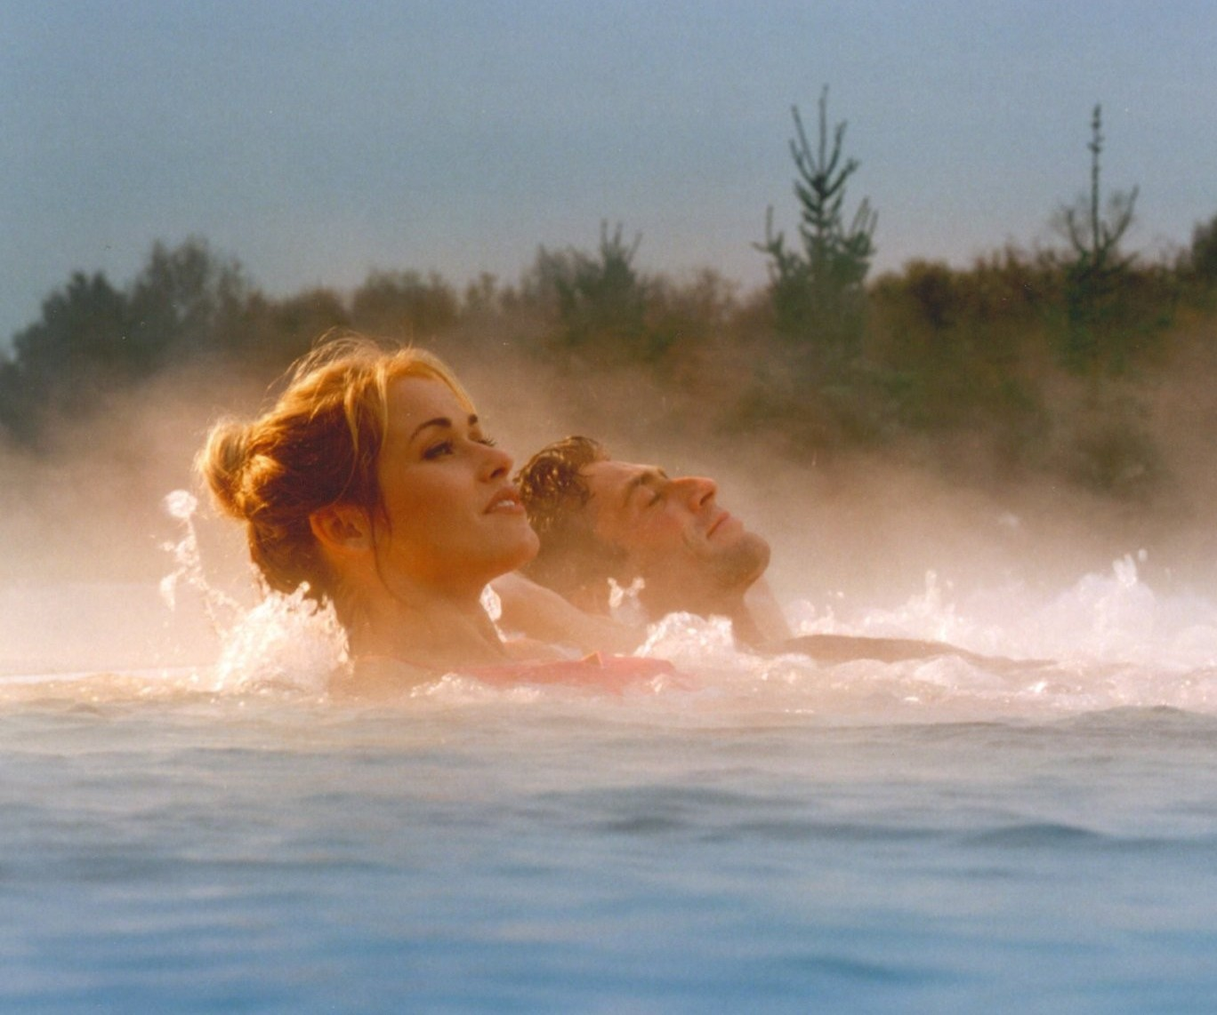 | With its stunning landscapes, the Lower Rhine is the perfect setting for an array of indoor and outdoor activities, including skiing, cycling, hiking, water-skiing, diving and surfing.  For those seeking a more relaxing break, visitors can enjoy one of the steaming outdoor thermal baths or stay in royal splendour at one of the many magnificent castles.

Top travel tips for the Lower Rhine

Stylish Shopping

Go designer shopping in Arnhem, boutique shopping in Venlo and Tiel, explore the Designer Outlet in Roermond or the new City Palais shopping mall in Duisburg.

Culture

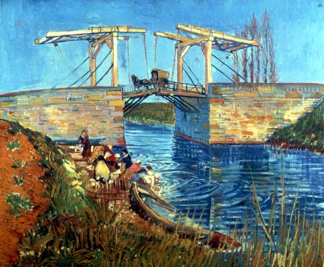 | The world’s largest outdoor fashion show, in Krefeld every September, showcases the latest designer collections.  Stay in a castle, such as the Jachslot Mookerheide in Moelenhoek or Wissen castle in Weeze.  Discover the Roman history of the region at the Xanten Archaeology Park and for art, visit the Kroller Muller Museum in the Veluwe or Castle Moyland in Bedburg Hau.

Wellness

The Scandic Sanadome in Nijmegen has pools filled with mineral-rich thermal water from the hotel’s own springs.

Step cross the border to Germany and visit Asia Therme where they use techniques from the Far East.

Get Active

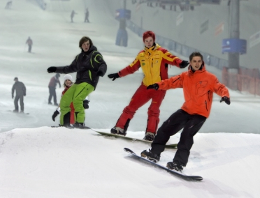 | Hit the slopes at the Ski Hall in Neuss with its perfect powder snow and slopes for all levels of ability.  Visit the Gasometer dive centre in Duisburg and take a dive in the largest indoor dive centre in Europe or for water sports, visit Freizeitzentrum Xanten, which offers sailing, water skiing, surfing and canoe or raft trips.
Christmas markets

Visit the magical Christmas markets of Kleve, Xanten or Arnhem in beautiful historic settings and offering a variety of seasonal delights such as gingerbread, Glühwine and traditional sausages.

www.coolbreaks.com

Where to stay in Holland

CitizenM Amsterdam

Voted as the world’s trendiest hotel 2010, CitizenM (short for Citizen Mobile) has earned an excellent reputation since it opened in Amsterdam’s city centre in April 2009.

This luxurious, but reasonably priced hotel has 215 rooms with innovative design created by award-winning design agency Concrete.

Rooms have wall-to-wall windows,XL king-size beds (more than 2 x 2 metres), power rain showers and Philips designed touch screen MoodPads which allow you to control everything in your room: television, music, window blinds, temperature, coloured lighting and wake-up alarm.

www.citizenm.com

Residenz, The Hague

Residenz is a unique boutique hotel, with the charm of a homely bed and breakfast, located in the heart of the lively Duinoord neighbourhood of The Hague, on the Sweelinckplein square.

The house was built in 1895 in preparation for the arrival of former emigrants returning from the Indias.

Throughout history the building served several purposes. Most recently it was home of the Spanish Consul-General. More than 110 years after it was built, Residenz opened its doors as a hotel.

www.residenz.nl/

The ss Rotterdam

The ‘ss Rotterdam, the most prestigious flagship and biggest passenger vessel of the Holland America Line, has opened as a luxury four-star hotel, conference venue and theatre.

With a permanent berth on the third Katendrechtse Hoofd in Rotterdam, the ship will sit at a central location in the city with a wonderful view of the Rotterdam skyline.

www.derotterdam.com (under construction)

The Grand Hotel Karel, Utrecht

The Grand Hotel Karel V is a five-star hotel located in a former 1349 convent and set within magnificent gardens in Utrecht city centre.

www.karelv.nl

Hotel Badhu, Utrecht

Hotel Badhu is known for its Arabic-inspired cuisine. Located in an old bathhouse, this hotel exudes an oriental atmosphere.

www.badhu.nl

The Kruisherenhotel, Maastricht

The Kruisherenhotel can be found in the city centre of medieval Maastricht.

This unique hotel was once a 15th-century Kruisheren monastery and a Gothic church before being transformed into a hotel, creating a unique mix between past and present architecture & design.

www.chateauhotels.nl/default.aspx?sc=7&taal=en

The Landal Waterparc Veluwemeer, Flevoland

The Landal Waterparc Veluwemeer, on the lake ‘Veluwemeer’ in Flevoland, opens in July 2010.

The complex comprises of beautiful apartments and characteristic villas, including deluxe 4-person apartments with sauna and 16-person villas.

www.landal.nl

Landgoed Jachtslot de Mookerheide, Lower Rhine

Landgoed Jachtslot de Mookerheide, a former hunting lodge, was built in 1902-1905 in art nouveau style by Jan Jacob Luden.

First privately owned, then a home for problem children run by the van Bethanië order of Dominican Sisters, in 1986 it was acquired by the current owner and turned into a luxurious castle hotel.

Fourteen of the twenty-one rooms are in the Palace de Jachthoorn, a separate building tucked away in the wooded parkland.

http://www.coolbreaks.com/hotel/landgoed,-jachtslot-de-mookerheide?lang=EN

Wissen Castle, Lower Rhine

Its tranquil setting in a picturesque park makes Wissen Castle a great place to escape the cares of everyday life.

Soak up the historical atmosphere of the castle in one of the suites and take breakfast in the former mill. The architectural history of the building spans a number of styles, from medieval to Renaissance to neo-Gothic.

http://www.coolbreaks.com/hotel/schloss-wissen?lang=EN

Expedia:

Short breaks to Holland can be sourced through Expedia

www.expedia.co.uk

How to get to Holland

By air

easyJet

easyJet flies to Amsterdam from the following UK airports: London Gatwick, Luton and Stansted, Edinburgh, Belfast, Liverpool, and Bristol. Prices from £29.99 single inc. taxes book now at easyjet.com.

Price correct as at 8 February 2010. For travel from 23 February to 24 April 2010. Variable charges for hold baggage apply and some payment methods attract a handling fee. See website for details.

www.easyjet.com

Other airlines that fly from the UK to Holland include KLM, bmibaby, British Airways, Aer Lingus, jet2.com, cityjet, Transavia.com and Ryanair.

By sea

Norfolk Line

Starting at just £31 for a car and up to four passengers from Dover - Dunkirk.

Valid for return trips of up to four days and for travel until 18th March 2010. To take advantage of the offer.

Visit www.norfolkline.com or call 0844 8475 007 from the UK quoting the promotional code: 4DAY.

www.norfolkline.com

DFDS Seaways

DFS Seaways offers :

- 2-night Keukenhof Gardens Mini Cruise. Departing Newcastle on 5, 10, 13, 17, 21, 27 Apr & 1 May 2010 from £99pp.

- 2-night ORCA Wildlife Watching Mini Cruise to Amsterdam. Departing Newcastle every other day between April and September from £69pp

www.dfdsseaways.co.uk

Other ferry companies that sail from the UK to Holland include P&O Ferries and Stena Line.

By sea

Eurostar

Eurostar services run from London St.Pancras, Ebbsfleet and Ashford International Stations to Brussels.

Regular and reliable connections also run from Brussels to cities and towns all over Holland.

Press trip itineraries

In 2010, group and individual press trips will be organised to:

- Keukenhof (26-28 March 2010)
- Amsterdam
- Rotterdam
- The Hague
- Utrecht
- Maastricht
- the Lower Rhine region (border region of Holland and Germany)
- the Sunparks resorts
- Friesland

Art focused group press trips will also be organised around the theme Holland Art Cities, including exclusive exhibitions by the famous Dutch Masters.

All dates are being confirmed.

Contact Evelina Sugintaite at esugintaite@holland.com

More information

For more information about Holland and images contact:

Evelina Sugintaite

Netherlands Board of Tourism & Conventions
PO Box 30783, London WC2B 6DH

T: +44 (0) 20 7539 7957 (not for publication)
F: +44 (0) 20 7539 7953
E: esugintaite@holland.com
W: www.holland.com

The International Travel Writers Alliance

 | The International Travel Writers Alliance represents travel writers, editors, broadcasters and photographers worldwide  The International Travel Writers Alliance  Tel: +44 0776 419 8286  E: Ashley@itwalliance.com

